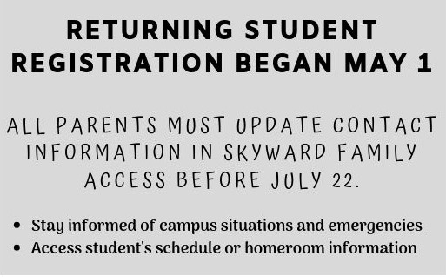
Pre-K
2 plastic folders w/brads (1 red, 1 blue)
4 dry erase markers
1 box washable markers 8ct
1 4 pack of playdough
1 container Clorox Wipes
8 purple glue sticks
1 pair of headphones for computer lab
(no earbuds please)
1 pkg 9x12 manila paper
1 set of watercolor paints
Teacher’s Wish List: dry erase markers, Clorox wipes, 12x18 manila paper

Kindergarten
1 ½ inch three ring binder
2 plastic folders w/brads (1 yellow,1 red)
2 spiral notebooks (70pg, wide ruled)
12 glue sticks
2 boxes crayons 24ct
1 box classic markers-10 count
4 skinny dry erase markers
1 pair blunt 5” scissors
12 pre-sharpened #2 wood pencils
1 bottle 8oz hand sanitizer
1 plastic supply box
1 pair of headphones (no earbuds please)
Boys: 1 box tissues and 1 pkg baby wipes
Girls: 1 box zipper sandwich bags and 1 container of Clorox wipes
Teacher’s Wish List: paper plates, dry erase markers, pencil cap erasers, tissues, watercolor paints

Follow Price Elementary online!

1st Grade
1 pair of blunt scissors
2 boxes crayons 24ct
8 glue sticks
4 dry erase markers (black only)
2 boxes of tissues
24 #2 pencils
4 plastic pocket folders w/brads
(1 yellow, 1 green, 1 blue, 1 red)
1 composition notebook, wide-rule
1 bottle hand sanitizer
1 pair of headphones (no earbuds please)
2 pink erasers
2 handwriting tablets (grades K-1)
1 box of quart size bags
1 pack of post-it notes
Teacher’s Wish List: Clorox wipes, watercolor paints

2nd Grade
1 pair of scissors
2 boxes crayons 24ct
1 package wide-ruled notebook paper
6 glue sticks
5 dry erase markers (black only)
2 highlighters
1 plastic pencil box
2 boxes of tissues
24 #2 wood pencils
(no colors/decorations please)
4 pocket folders w/brads (1 yellow, 1 green, 1 blue, 1 red) plastic preferred
4 composition notebooks, wide-rule
1 bottle hand sanitizer
1 pair of headphones (no earbuds please)
1 one-inch binder (with front cover pocket)
Teacher’s Wish List Items: post-its, skinny black dry erase markers

3rd Grade
24 #2 wood pencils (no mechanical)
2 pink bevel erasers (latex free)
3 70 ct. college ruled spiral notebooks
2 college ruled composition notebooks
1 box crayons 24ct
1 box colored map pencils 12ct
1 pair 5” sharp scissors
4 glue sticks
3 boxes of tissues
1 plastic school supply bag
1 1 ½ inch binder
1 set of 5 dividers w/pockets for binder
1 bottle hand sanitizer
1 pair of headphones
Teacher’s Wish List Items: gallon and quart size baggies, 12x18 manila paper

4th Grade
24 #2 wood pencils
4 composition notebooks
1 box colored map pencils
4 pocket folders w/brads
1 safety scissors
3 glue sticks (no bottles)
1 pencil bag or box
3 boxes of tissues
1 box of markers
1 pack of dry erase markers (4 pack)
1 pair of headphones or earbuds
$4.00 for music recorder
Teacher’s Wish List Items: Clorox wipes, hand sanitizer

5th Grade
10 pre-sharpened #2 wood pencils
4 highlighters
3 pink erasers
4 composition notebooks
1 one-inch binder
6 glue sticks
3 boxes of tissues
1 pair of scissors
1 box colored map pencils
2 pocket folders (1 red, 1 green)
1 pair of headphones or earbuds
$4.00 for music recorder
Optional: Clorox wipes, hand sanitizer, post-it notes, washable markers

Follow Price Elementary online!

